High Power Rocketry Airframe Integration: Optimizing Static Stability for G and H- Class Propulsion Systems
By Wildania Baez Polanco

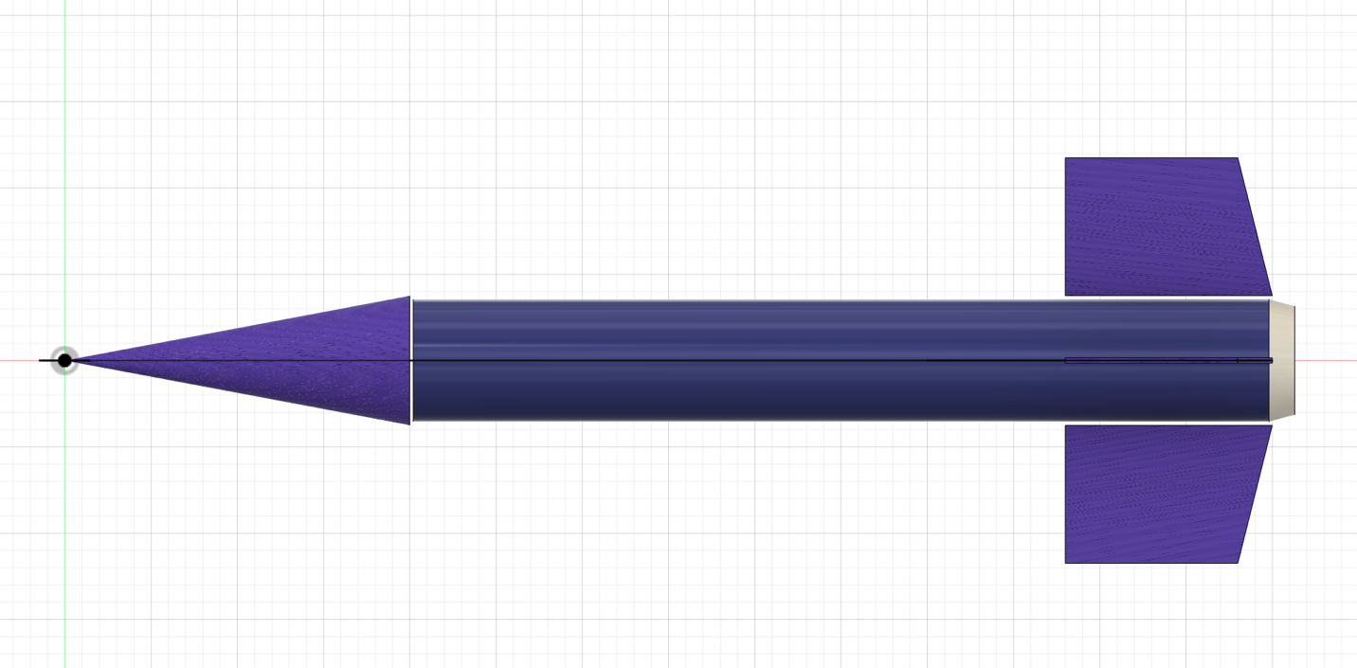
Figure 1: Final CAD for Rocket
Summary
This report presents the aerodynamic design, structural configuration and flight simulation analysis for costume 70 cm launch vehicle. The objective of this project t was to evaluate the impact of escalating propulsion capabilities, specifically stepping up from mid-power to high-power rocket motors on the vehicle’s static stability margin. Initial simulations revealed dangerous stability degradation due to a massive rearward shift in the Center of Gravity (CG). To resolve this flight dynamic hazard, a custom, removable nose cone ballast system was engineered to restored aerodynamic stability and ensure safe flight parameters.

Vehicle Specification (digital)
The physical structure of the airframe was modeled using precise engineering dimensions to create a functional digital twin.
Table 1: Vehicle Specifications
Component | Geometric Profile | Value | Material Selection
Nose Cone | Conical Shape | Length: 20 cm  Outer Diameter:  7.5 cm  Inner Diameter:  7.1 cm | Cardboard
Body Tube | Cylindrical Shell | Length: 50 cm  Outer Diameter:  7.5 cm  Inner Diameter:  7.1 cm | Cardboard
Inner Motor Tube | Internal Guide | Length: 20 cm  Outer Diameter: 3.1cm  Inner Diameter: 2.9cm | plywood
Fins(x4) | Trapezoidal | Root Chord: 12 cm  Tip Chord: 6 cm  Height: 8 cm  Sweep Length: 4 cm  Thickness: 0.3 cm | Plywood
Recovery System | Parachute | Diameter: 60 cm | Nylon

The Core Engineering Problem
A fundamental principle of rocketry physics dictates that for a vehicle to achieve a stable flight; CG must always it forward of the Center of Pressure (CP)
Unloaded Baseline: With no motors installed, the structural airframe demonstrates an initial mass of 265g. Establishing a stable baseline with CG at 45.6 cm and CP at 54.2 cm, resulting in a static stability margin of 1.15 cal.
Hypothesis: Loading larger, heavier propulsion systems degrades the static stability of a fixed airframe. As larger motors add massive weight to the absolute rear of the rocket, the CG moves backward toward the tail, shrinking the safe distance between the CG and the CP
Table 2: Stability Degradation Under Heavy propulsion
Motor Configuration | Motor Details | Center of Gravity (CG) | Center of Pressure (CP) | Resulting Static Stability | Flight Safety Status
No motor | Empty Airframe | 45.6 cm | 54.2 cm | 1.15 cal | Safe(optimal)
Motor 1: G76G-6 | Mid-Power/Low-HPR Boundary | 52.1 cm | 54.2 cm | 0.28 cal | Unsafe(critical)
Motor 2: 38mm H130W-7 | High Power Rocketry (HPR) | 53.6 cm | 54.2 cm | 0.089 cal | Severe Danger (catastrophic)

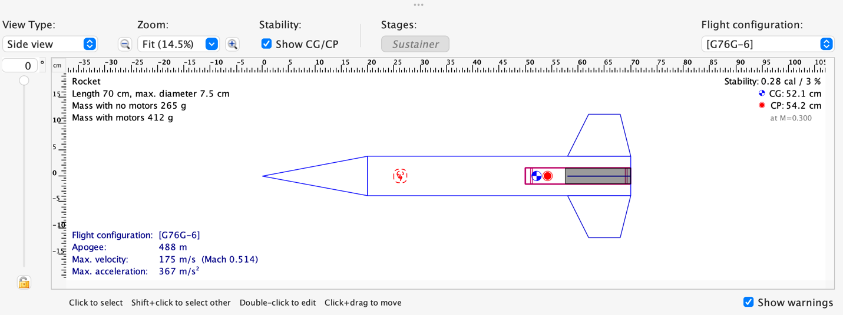
Figure 2: OpenRocket Model with G-Power Motor
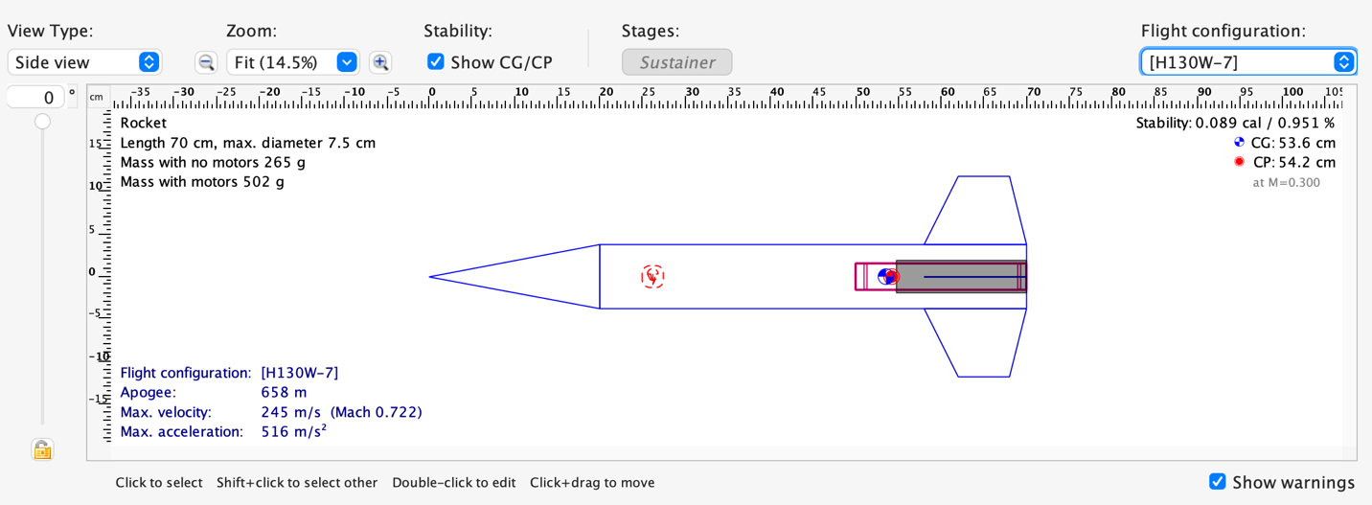
Figure 3: OpenRocket Model with H-Power Motor

The Engineering Solution: Removable Nose Cone Ballast System

To counter the rearward weight shifts and restore the require safety parameters (1.0 cal to 2.0 cal margin), a variable mass system was developed. By creating a removable nose cone ballast system, rather than utilizing a single fixed weight, a removable ballast container was designed inside the nose cone. This allows the addition or subtraction of mass increments depending on the specific minimum weight required to counter the loaded motor.
G-Motor Correction: Adding a 50g weight increment into the ballast container successfully shifted the CG forward, recovering a safe flight stability of 1.01 cal.
H-Motor Correction: Because the H-class motor is significantly heavier, a 50g mass addition only brought stability up to 0.721 cal. This demonstrates that the ballast container must be loaded with a heavier mass configuration (optimized up to an 80g counterweight framework) to adequately shift the CG forward and safe the vehicle for high-power H-motor flights.
Table 3 : Simulated Flight Dynamis Data
Motor Class | Launch Rail Velocity | Time to Apogee | Peak Acceleration | Maximum Velocity | Apogee | Flight Time | Ground Hit Velocity
G- motor | 23.9 m/s | 8.13s | 297m/s*s | 155 m/s | 492 m | 95.1s | 6.04 m/s
H- motor | 29.5 m/s | 8.94s | 432m/s*s | 228 m/s | 687 m | 126s | 6.16 m/s

Figure 4 and 5: OpenRocket multi-variable flight performance curves detailing altitude, vertical acceleration, and vertical velocity profiles across both optimized motor configurations.
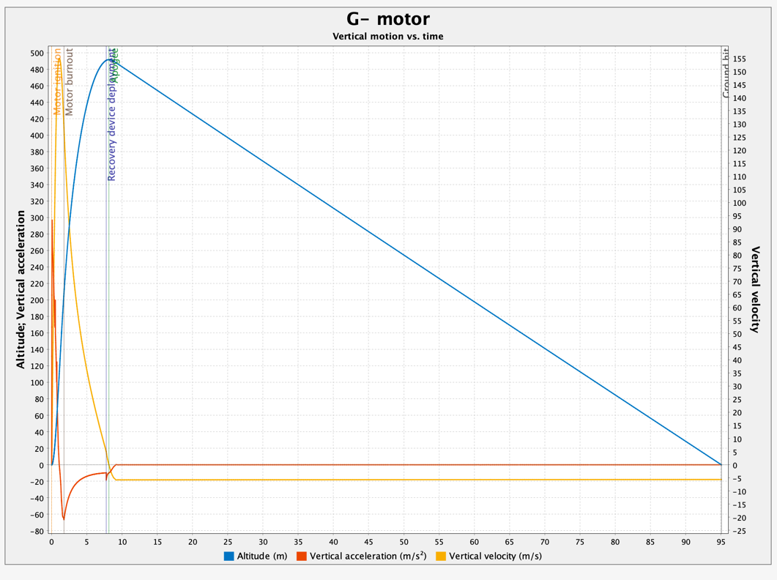
Figure 4: Simulation 1: Vertical Motion vs. time for G-motor
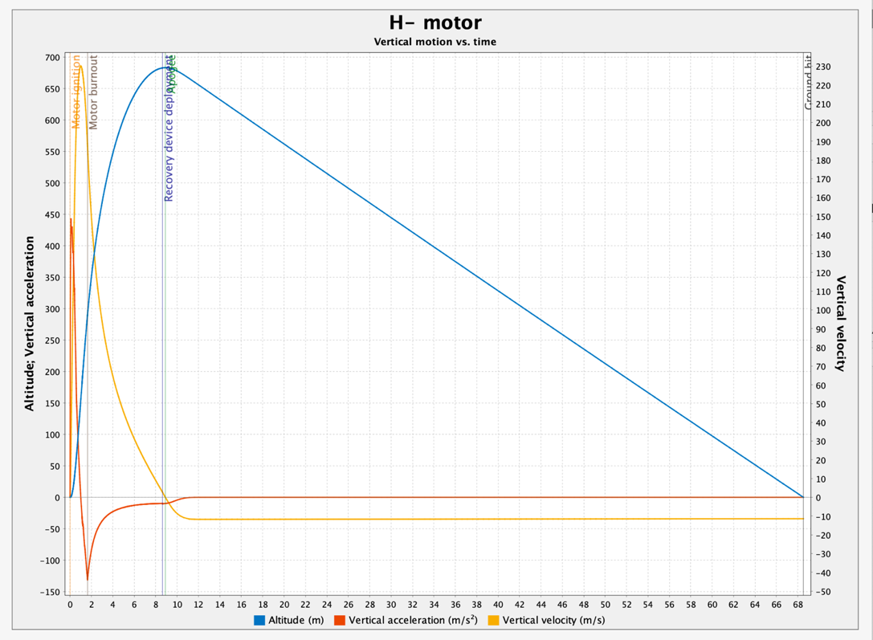
Figure 5: Simulation 2: Vertical Motion vs. time for H-motor

Optimization
Initial data tracking showed that during the H-motor simulation, the default parachute deployment charge fired while the rocket airframe was traveling at a velocity that was too high. To avoid high-speed parachute shredding or structural tearing, the motor's internal black powder mechanical delay must be modified from a 6-second delay to 7 second. This alteration guarantees that deployment occurs exactly at apogee when vertical velocity drops closest to 0 m/ensuring a safe descent speed of roughly 6.16 m/s back down to ground hit.

Conclusion
By combining thermodynamic propulsion simulation data with structural CAD implementation, this project demonstrates a complete aerospace design loop. The physical layout accommodates the extreme structural acceleration demands 443 m/s*s of high-power rocketry while proving that dynamic balance can be maintained externally via modular counterweights.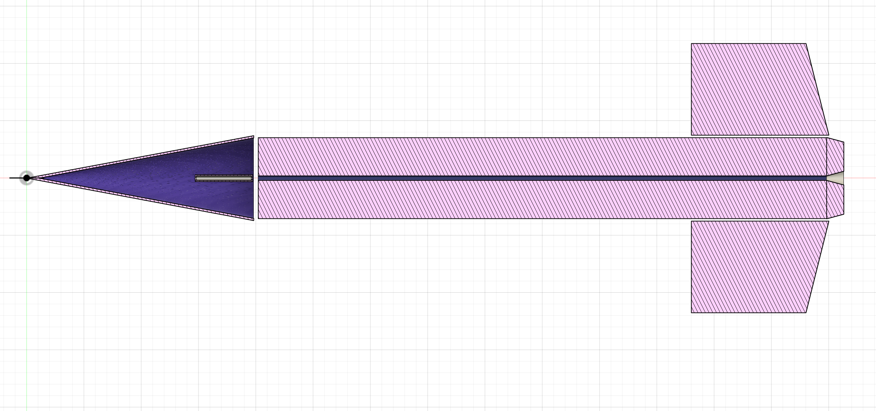
Figure 6: Section analysis displaying the internal hollow cavity and the custom-designed concentric weight compartment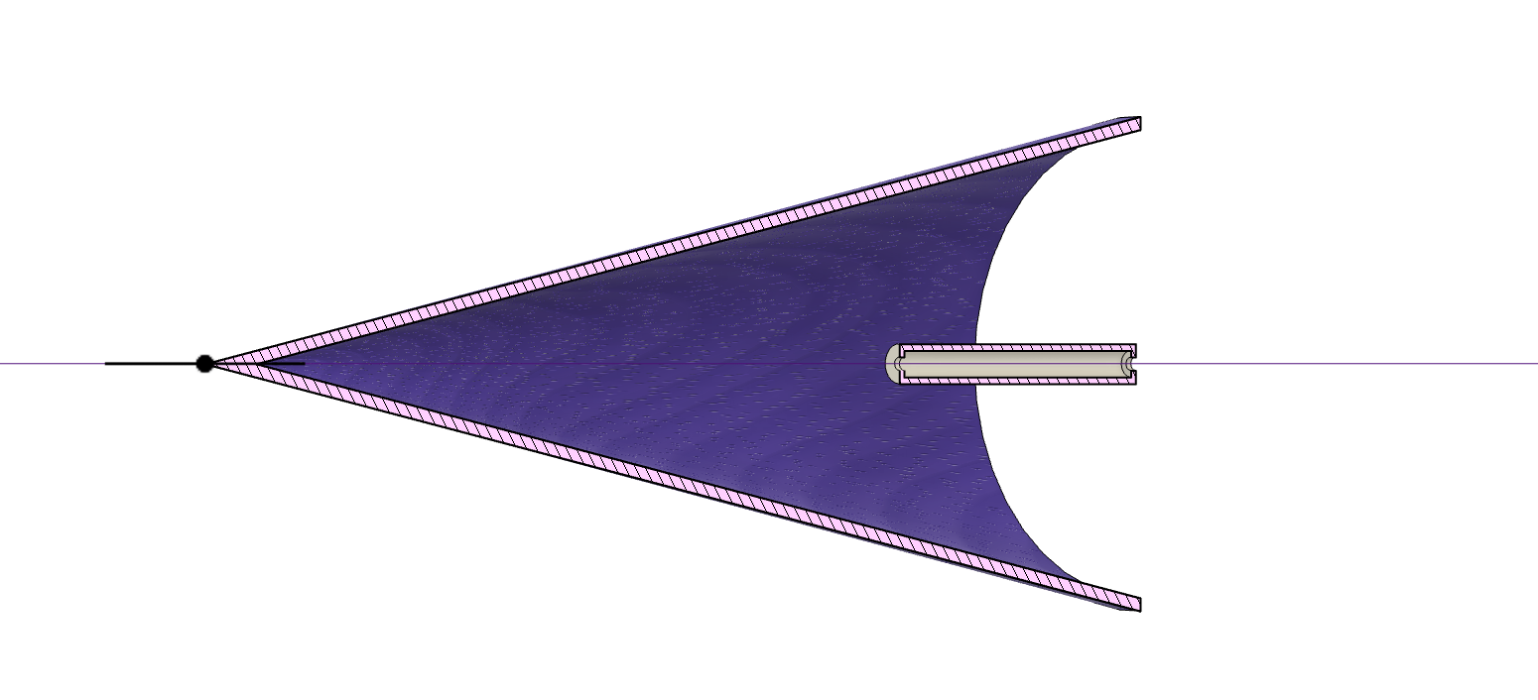
Figure 7: Close view of Nose Cone and empty weight compartment

